# CS 255 System Design Document Template

## UML Diagrams

### UML Use Case Diagram

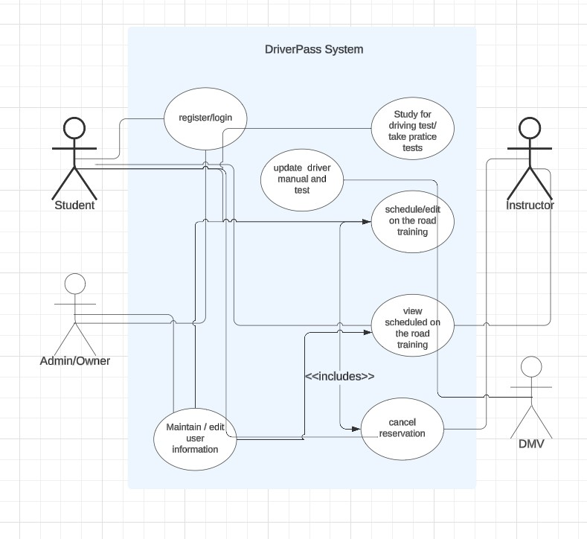

### UML Activity Diagrams

User login/register activity diagram

User wants to study driver manual or take practice test activity diagram

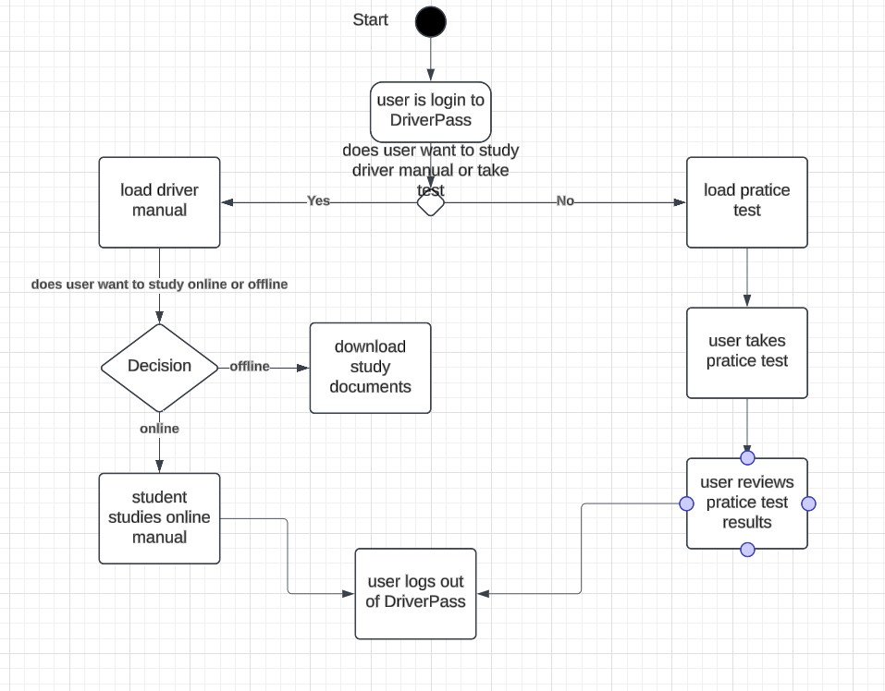

### UML Sequence Diagram

Study or take practice test sequence diagram

### UML Class Diagram

## Technical Requirements

*[Based on the diagrams you have created, describe the technical requirements of your system. These requirements should address the required hardware, software, tools, and infrastructure necessary for your system design.]*

**Hardware Requirements:**

* Web based application.
* Compatible with all major browsers that run on mobile and computer devices.
* Cloud storage/backup for database, application data, and user information.

**Software Requirements:**

* Windows Apache server.
* Windows defender for security.
* SQL Server for database.
* The front end will use JavaScript HTM and CSS programming languages.
* The backend will use Java and SQL programming languages.

**Tools:**

* GitHub will be used as the development platform.
* Developers can use visual studio code or Eclipse IDE.